VISVESVARAYA TECHNOLOGICAL UNIVERSITY, BELAGAVI - 590 018

Mini Project Report On
RESORT MANAGEMENT SYSTEM
A report submitted in partial fulfilment of the requirements for
DATABASE MANAGEMENT SYSTEM LABORATORY WITH MINI PROJECT(BCS403)
in
CSE(DATA SCIENCE)

Submitted by

ABHISHEK N M 4AL23CD002
YASHAVANTH A 4AL23CD063

Under the Guidance of
Mr. Lohith B
Assistant Professor


DEPARTMENT OF COMPUTER SCIENCE & ENGINEERING (DATA SCIENCE)
ALVA’S INSTITUTE OF ENGINEERING AND TECHNOLOGY
MOODBIDRI-574225, KARNATAKA
2024 – 2025
ALVA’S INSTITUTE OF ENGINEERING AND TECHNOLOGY
MOODBIDRI-574225, KARNATAKA


DEPARTMENT OF CSE(DATA SCIENCE)

CERTIFICATE
This is to certify that the Mini Project entitled RESORT MANAGEMENT SYSTEM has been successfully completed by

ABHISHEK N M | 4AL23CD002
YASHAVANTH A | 4AL23CD063

in the partial fulfilment for the award of Degree of Bachelor of Engineering in Computer and Engineering of the Visvesvaraya Technological University, Belagavi during the year 2024-
2025. It is certified that all corrections/suggestions indicated have been incorporated in the report. The
Mini project report has been approved as it satisfies the academic requirements in respect of Mini Project Work prescribed for the award of Bachelor of Engineering Degree.

Mr. LOHITH B Prof. HARISH KUNDER

External Viva

Name of the Examiners Signature with Date
1. 2.

ALVA’S INSTITUTE OF ENGINEERING AND TECHNOLOGY
MOODBIDRI-574225, KARNATAKA

DEPARTMENT OF CSE (DATA SCIENCE)

DECLARATION

We,
ABHISHEK N M

YASHAVANTH A

Hereby declare that the dissertation entitled, RESORT MANAGEMENT SYSTEM is completed and written by us under the supervision of our guide Mr. Lohith B, Assistant Professor Department of Computer Science and Engineering, Alva’s Institute of Engineering and Technology of the Visvesvaraya Technological University, Belagavi during the year 2024- 2025.The dissertation report is original and it has not been submitted for any other degree in any university.

ABHISHEK N M 4AL23CD002

YASHAVANTH A 4AL23CD063

ACKNOWLEDGEMENT

The satisfaction and euphoria that accompany a successful completion of any task would be incomplete without the mention of people who made it possible, success is the epitome of hard work and perseverance, but steadfast of all is encouraging guidance.
So, with gratitude we acknowledge all those whose guidance and encouragement served as
beacon of light and crowned the effort with success.
The selection of this mini project work as well as the timely completion is mainly due to the interest and persuasion of our mini project coordinator Mr. Lohith B, Assistant Professor, Department of Computer Science & Engineering. We will remember his contribution for ever.
We sincerely thank, Mr Harish Kunder, Professor and Head, Department of Artificial Intelligence and Machine Learning who has been the constant driving force behind the completion of the project.
We thank our beloved Principal Dr. Peter Fernandes, for his constant help and support
throughout.
We are indebted to Management of Alva’s Institute of Engineering and Technology, Mijar, Moodbidri for providing an environment which helped us in completing our mini project.
Also, we thank all the teaching and non-teaching staff of Department of Artificial Intelligence
and Machine Learning for the help rendered.

ABHISHEK N M 4AL23CD002

YASHAVANTH A 4AL23CD063

ABSTRACT

This mini-project aims to design and implement a Database Management System (DBMS) for managing and organizing data related to resort management, including room schedules, customer information, booking details, and assigned records. The primary objective is to build a structured, relational database using MySQL and provide a user-friendly web interface for booking and managing reservations using PHP.

The project includes the creation of multiple interrelated tables representing entities such as Rooms, Customer, Bookings and assigned. SQL scripts are used to define the database schema and populate it with sample data. The system currently supports core data retrieval and viewing operations, with the potential to expand into full CRUD (Create, Read, Update, Delete) functionalities for comprehensive reservation management.

The interface is developed using Flask, a lightweight Python web framework that bridges the MySQL database with a web-based front end. This allows users to browse available rooms, make reservations, view their booking history, and access relevant rooms and customer details interactively through a browser.

This mini-project serves as a practical application of fundamental DBMS concepts, including data modeling, entity-relationship design, schema creation, normalization, and SQL query execution. It also introduces foundational full-stack development by combining Python for backend logic and HTML/CSS for frontend rendering. Overall, this project provides hands-on experience in building a database-driven application that integrates database management with dynamic web development skills.

TABLE OF CONTENTS

CHAPTER NO. | DESCRIPTIONS | PAGE NO.
1. | INTRODUCTION | 1-2
 | 1.1 Database & Project Topic
2. | SOFTWARE REQUIREMENTS | 3-4
2.1 Hardware Specifications
2.2 Software Requirements
3. | SYSTEM ANALYSIS DESIGN | 5-11
4. | DATABASE TECHNIQUE AND RESULTS | 12-15
5. | SNAPSHOTS | 16-20
6. | CONCLUSION | 21
7. | REFERENCES | 22

 | LIST OF FIGURES
FIGURE NO. | TITLE | PAGE  NO.
3.1 | ER diagram | 6
3.2 | Schema diagram | 7
4.3 | Administrator Table | 9
5.1 | SnapShots | 20

Chapter 1

INTRODUCTION

1.1 Overview:
Resort Management System is a room reservation site script where site users will be able to search rooms availability with an online booking reservations system. Site users can also browse resort, view room inventory, check availability, and book reservations in real-time. Site users enter check in date and check out date then search for availability and rates. After choosing the right room in the wanted resort, all booking and reservation process is done on the site and an SMS is sent to confirm the booking.
In administrator panel,

- Administrator – Administrator can manage administrator accounts and conform the rooms.
- Room Types – Administrator can define the type of rooms in the hotels, room’s prices and upload an image for each room.
- Bookings – All booking and reservations maid on the site are displayed with all booking details: arrival date, departure date, hotel name, room type, number of passengers, price.

  - Problem Statement:
The Main Objective of resort management system is improved by integrating service-oriented operations with project management principles. By managing each change as a project, embedded in smoothly running operations, hotels would extend their life span by continuously reinventing themselves. Due to which the customers can easily book the hotel rooms. This system will help administration to work easily.

  - Existing System:

- Data is not always reliable as it is hand written and some human errors might have occurred example wrong telephone number among other.
- Slow process of reservation. User has to find manually whether room is available ornot
- Hotel information data are not secured. It can be easily theft or altered.
- Finding records are very time consuming.
- Retrieval of guest records is extremely difficult. User has to manually search each record to find the required information. It takes lot of time.

1.3.1 Drawbacks:

- Time Consuming

- Pressurized
- Inaccurate information

- May adversely affect by missed/unknown information.

1.4 Proposed System:

- To overcome the problems of manual system and 3rd party platform issues Resort Management System is proposed. 
- Customer can directly communicate with the Resort. 
- The communicate objective of resort management system is to provide online facility for accessing all the facility of resort. 
- This software can manage and keep records of resort online. 

1.5 Advantages:

- Save time of customer in quickly reserving all the facility of resort.

- Provides the information about the resort facilities.

- User friendly.

- Very secure.

Chapter 2

SOFTWARE REQUIREMENTS

2.1 Software Used:

Operating system: Windows 98, XP, 7,8 or 10 or Linux Languages (Front end): HTML, PHP and Bootstrap
(Back end): SQL
IDE: Notepad++, Xampp and MySQL

2.2 Software Description:

2.2.1 XAMPP(PhpMyAdmin)

PhpMyAdmin can manage a whole MySQL server as well as a single database. To accomplish the latter, you'll need a properly set up MySQL user who can read/write only the desired database. It's up to you to look up the appropriate part in the MySQL manual.
- browse and drop databases, tables, views, columns and indexes 
- create, copy, drop, rename and alter databases, tables, columns and indexes 
- maintenance server, databases and tables, with proposals on server configuration 
- execute, edit and bookmark any SQL-statement, even batch-queries 
- load text files into tables 
- create and read dumps of tables 
- export data to various formats: CSV, XML, PDF, ISO/IEC 26300 – Open
Document Text and Spreadsheet, Word, and L^{A}T_{E}X formats 
- import data and MySQL structures from Open Document spreadsheets, as well  as XML, CSV, and SQL files
- administer multiple servers 
- manage MySQL users and privileges 
- check referential integrity in MyISAM tables 
- using Query-by-example (QBE), create complex queries automatically connecting required tables 
- create PDF graphics of your Database layout 
- search globally in a database or a subset of it 
- transform stored data into any format using a set of predefined functions, like displaying BLOB-data as image or download-link 
- track changes on databases, tables and views 
- support InnoDB tables and foreign keys 
- support mysqli, the improved MySQL extension 
- create, edit, call, export and drop stored procedures and functions 
- create, edit, export and drop events and triggers 
- communicate in 
- synchronize two databases residing on the same as well as remote servers . 

2.2.2 PHP:
- You need PHP 5.2.0 or newer, with session support, the Standard PHP Library
(SPL) extension and JSON support. 
- To support uploading of ZIP files, you need the PHP zip extension. 
- For proper support of multibyte strings (eg. UTF-8, which is currently the default), you should install the mbstring and ctype extensions. 
- You need GD2 support in PHP to display inline thumbnails of JPEGs
("image/jpeg: inline") with their original aspect ratio 
- When using the "cookie" authenticated method, the mcrypt extension is strongly suggested for most users and is required for 64–bit machines. Not using mcrypt will cause phpMyAdmin to load pages significantly slower. 

Chapter 3

SYSTEM ANALYSIS AND DESIGN

3.1 System Analysis
System analysis is a detailed of the various operations performed by a system and their relationship within and outside the system. It is a systematic technique that defines goals and objectives. The goal of system development is to develop a system in line with the user requirement, and analysis of the system plays important role. One of the main aspects of analysis is the defining the boundaries of the system.
The various tools of structured analysis are:
- Entity relationship diagram 
- Table 
- Table description 
- Flow diagram 

The structured analysis has the following attributes:

- Entity relationship diagram (ER-Diagram) is a graphical representation of entities and their relationship to each other, typically used in computing in regards to the organization of data within data base. Here, we are explaining the system, modules and their relationship using ER-Diagram. 
- The Data Flow Diagram (DFD) presents a picture of what is being specified and is conceptually easy to understand presentation of the application. 
- Table is the logical model of storing data with its attribute and data type. 

3.2 USE CASE DIAGRAM
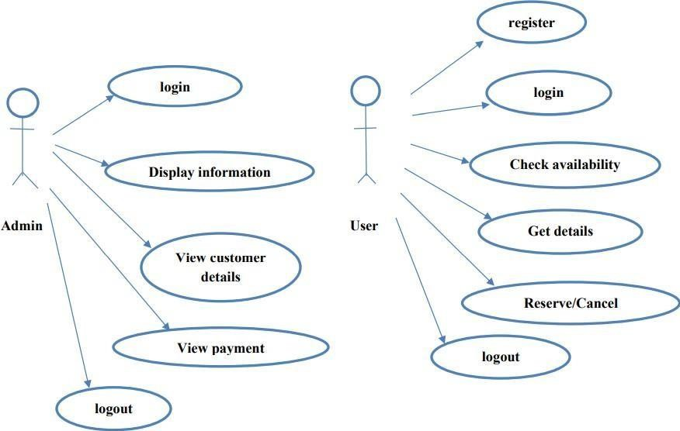

Fig:(a) Use case diagram for admin Fig:(b) Use case diagram for user

Fig3.2 Use case Diagram for Resort Management System

3.3 DATA FLOW DIAGRAM FOR ADMIN:

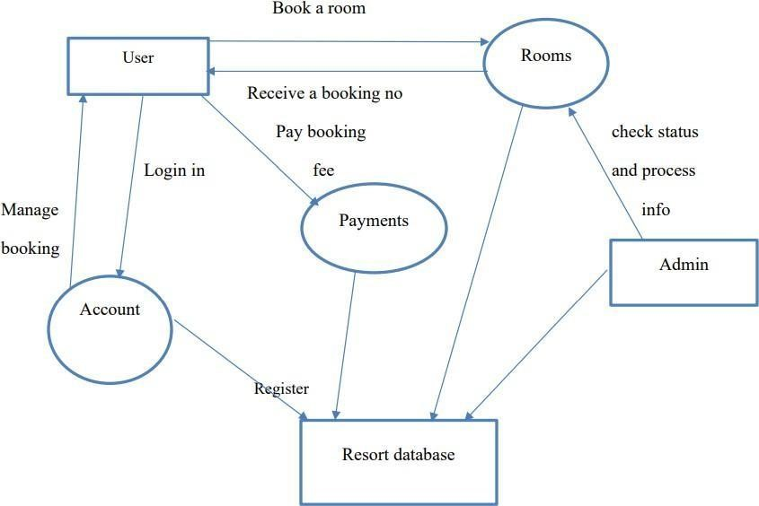

Fig 3.3: Data flow diagram for Resort Management System

3.4 E. R DIAGRAM:
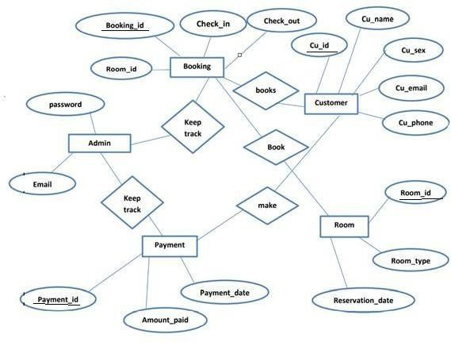

Fig 3.4: E R Diagram for Resort Management System

3.5 E. R Mapping to Physical Schema Diagram

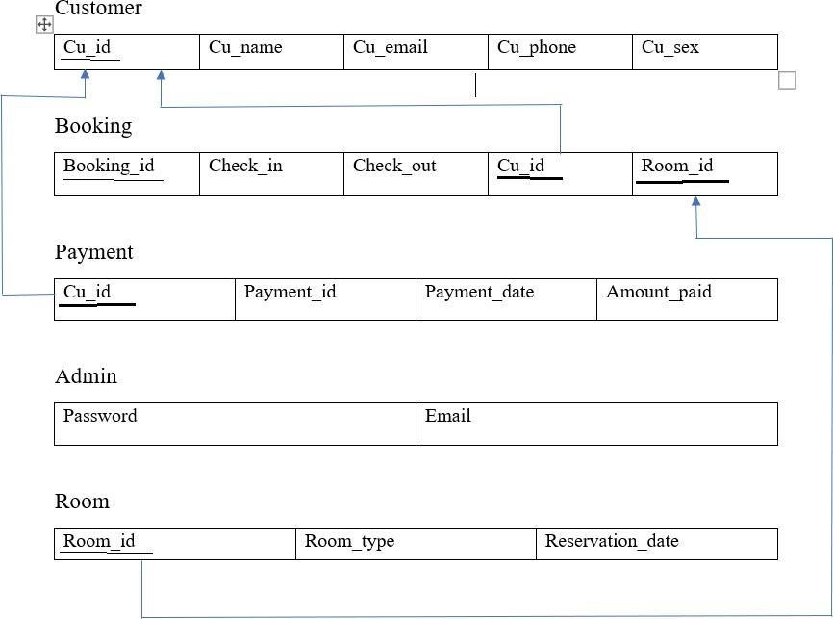

Fig 3.5: Database schema diagram for Resort Management System

3.6 TABLES DESCRIPTION

- The “assigned_room” table provides all the information about the Rooms Assigned for a Customer. 

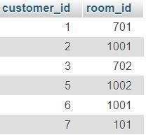
- The “login” table provides all the information about the Customers that are Login. 

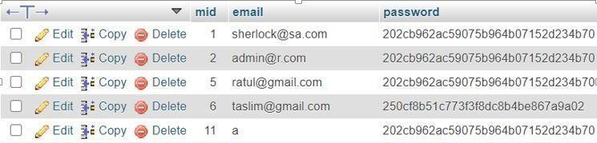

- The “manager” table provides all the information about the Registration. 

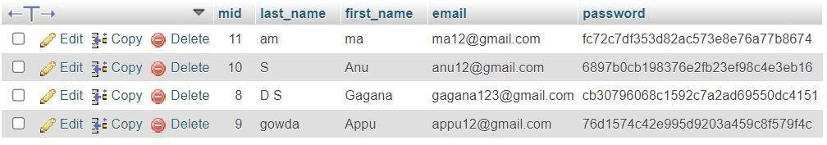

- The “request_room” table provides all the information about the Customer. 

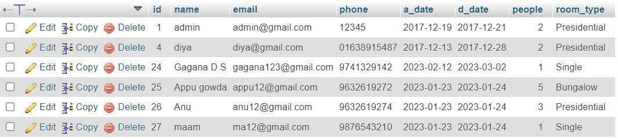
- The “resort_rooms” table provides all the information about the Types of Room available in Resort. 

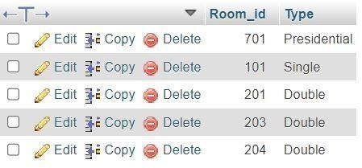
Chapter 4

DATABASE TECHNIQUE AND RESULTS

4.1 TRIGGER:

- There is a basic trigger in this project. ➢ If we request room, then the TRIGGER updates the status of room book.

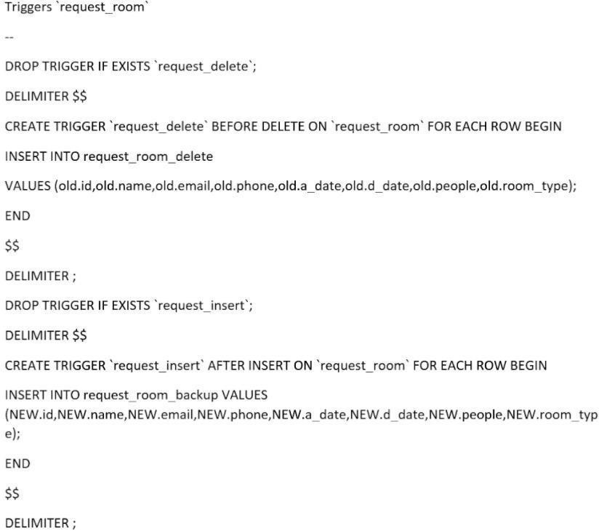

4.2 NORMALIZATION:

The complete tables of the database in the project are normalized, obeying all the rules of normalization
1NF:
1NF disallows relations within relations or relations as attribute values within tuples. The only attribute values permitted by 1NF are single atomic (or indivisible) values.
2NF:
A functional dependency X → Y is a full functional dependency if removal of any attribute A from X means that the dependency does not hold any more; that is, for any attribute A ε X, (X – {A}) does not functionally determine Y.
3NF:

Transitive functional dependency
A functional dependency X→Y in a relation schema R is a transitive dependency if there exists a set of attribute Z that are neither a primary nor a subset of any key of R (candidate
Definition: A relation schema R is in third normal form (3NF) if it is in 2NF and no non- prime attribute A in R is transitively dependent on the primary key.

CUSTOMER

 | Cu_id (primary key) | Cu_name |  | Cu_email |  |  |  | Cu_phone |  |  | Cu_sex
 | BOOKING
 | Booking_id (primary key) | Check_in |  | Check_out |  |  |  | Cu_id (foreign key) |  |  | Room_id  (foreign key)
 | PAYMENT
 | Payment_id (primary key) |  | Cu_id (foreign key) |  |  | Payment_date |  |  |  | Amount_paid
ROOM
Room_id (primary key) |  |  |  |  | Room_type |  |  |  | Reservation_date
ADMIN
email |  |  |  |  |  |  | password

CUSTOMER


FD1

Cu_id

primary
(
key)

Cu_name

Cu_email

Cu_phone

Cu_sex


BOOKING

Booking_id

(
primary

key)

Check_in

Check_out

Cu_id

foreign
(
key)

Room_id

(
foreign

key)

FD2


Payment_id

primary
(

key)

FD3

PAYMENT

Cu_id

foreign
(

key)

Payment_date

Amount_paid

ROOM


Room_id

primary
(

key)

FD4

Room_type

Reservation_date

1NF: In the above table there are no multi valued attributes. Thus, the functional dependency FD1 and relation satisfies 1NF.
2NF: There are no partial dependencies found in the above defined functional dependencies. Thus, we can say that relation satisfies 2NF.

3NF: There are no transitive dependencies found in the above defined functional dependencies. Thus, we can say that relation satisfies 3NF.

4.4 TESTING:

No | Test Cases | Case Type | Expected Result | Actual Result | Pass/Fail
1 | Login | 1.Invalid ID | The system will not accept the invalid  ID and  throws message | The system will not allow to  login into the system | Pass
 |  | 2.Invalid Password | The system will not accept the invalid  Password and throws message | The system will not allow to  login into the system | Pass
2 | Validation Testcase | 1.Require field validation | Field should not be empty | Users have to enter the value | Pass

CHAPTER 5

SNAPSHOTS

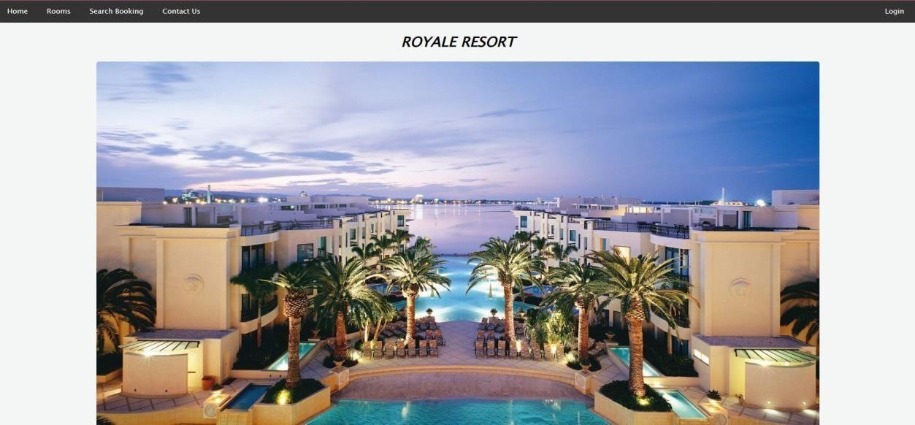

Fig 5.1: Home page
A home page is the default or front page of a site. It is the first page that visitor see when they load a URL. Web managers can control the home page as a way of directing the user experience.

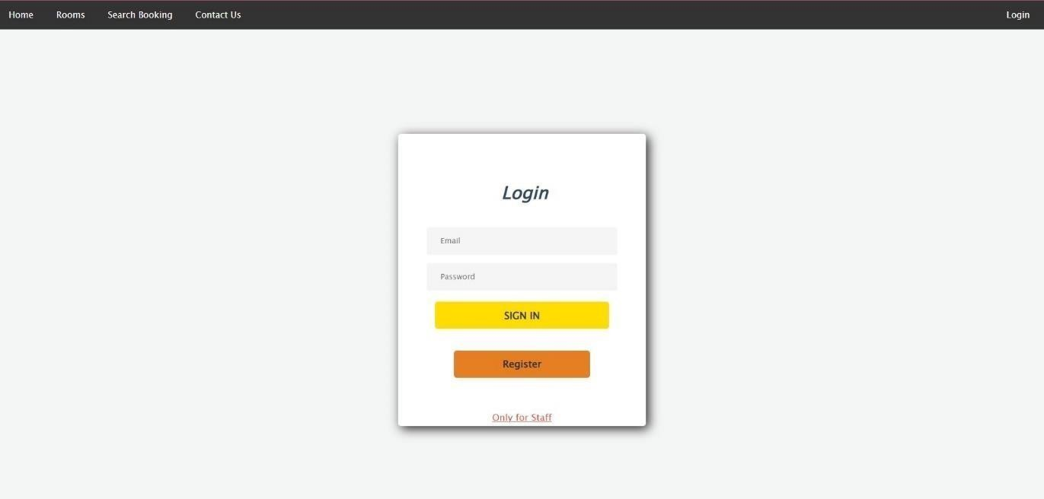

Fig 5.2: Login page
The login page allows a user to gain access to an application by entering their username and password or by authenticating using a social media login.
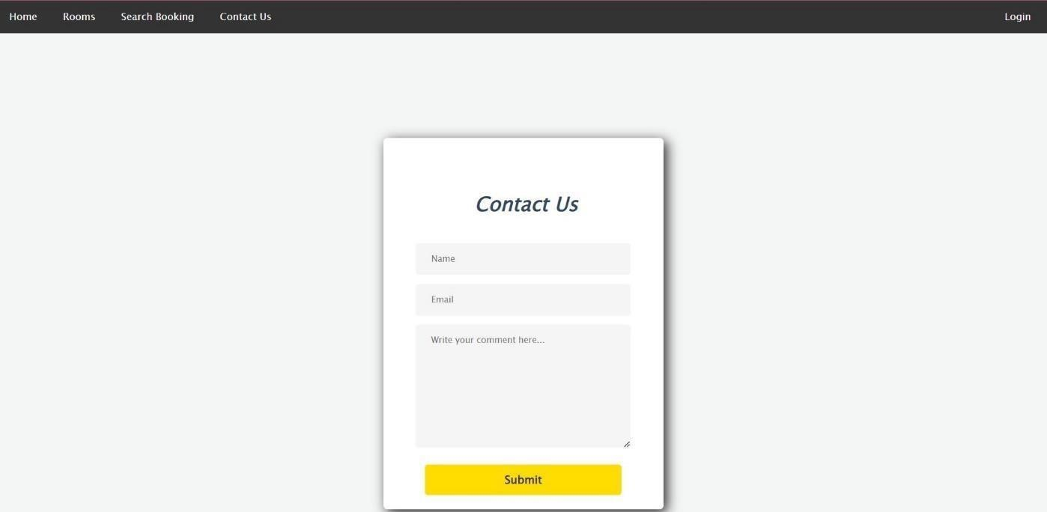

Fig 5.3: Contact us form
A contact page is common web page on a website for visitor to contact the organization providing the website. The page contains one or more of the following items: an e-mail address, name and comment.

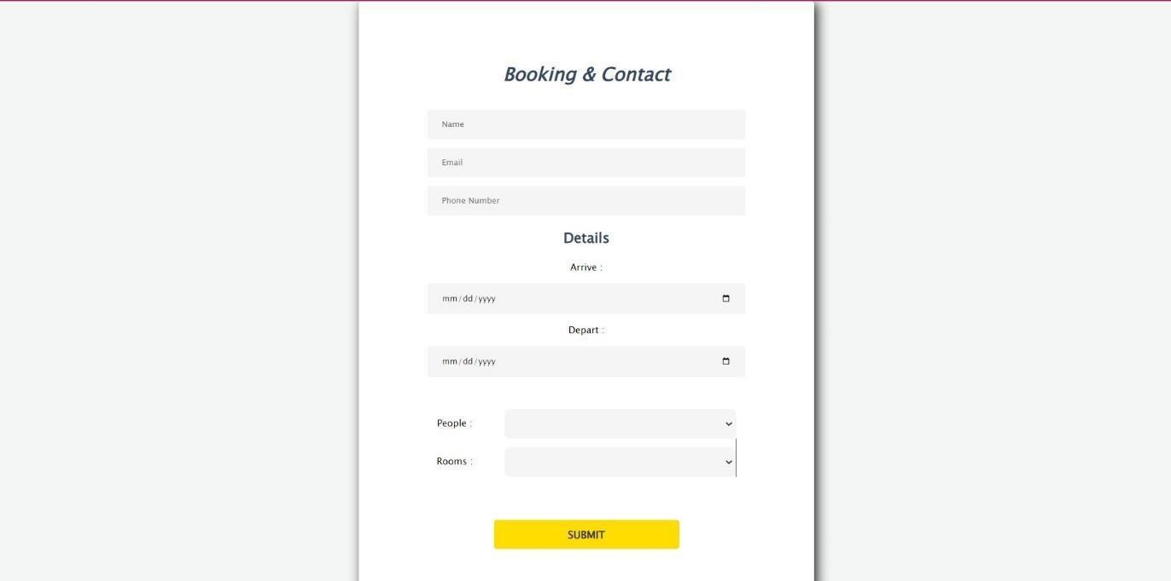

Fig 5.4: Booking and Contact page

All booking and reservations maid on the site are displayed with all booking details: arrival date, departure date, resort name, room type, number of passengers. A contact page is common web page on a website for visitor to contact the organization providing the website. The page contains one or more of the following items: an e-mail address, a phone number.
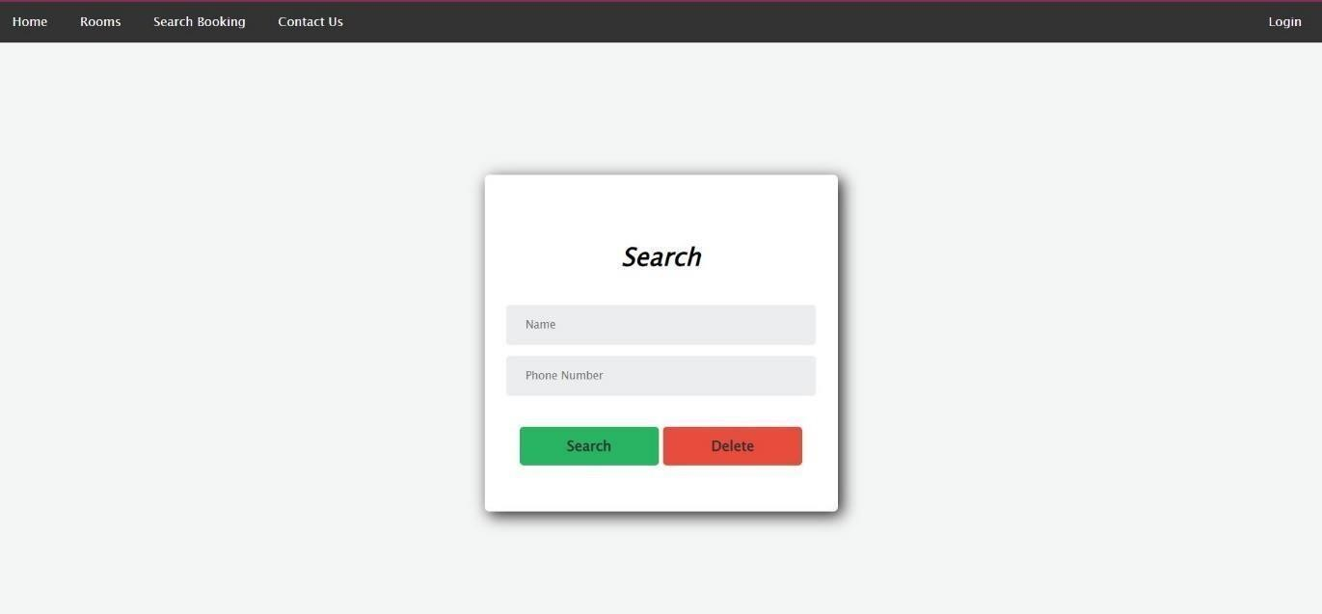

Fig: 5.5: Search and Booking page
All booking and reservations maid on the site are displayed with all booking details: arrival date, departure date, resort name, room type, number of passengers.

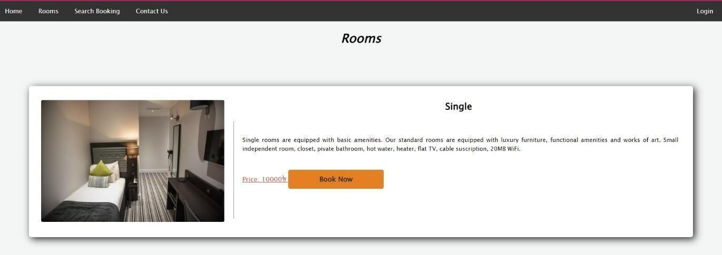
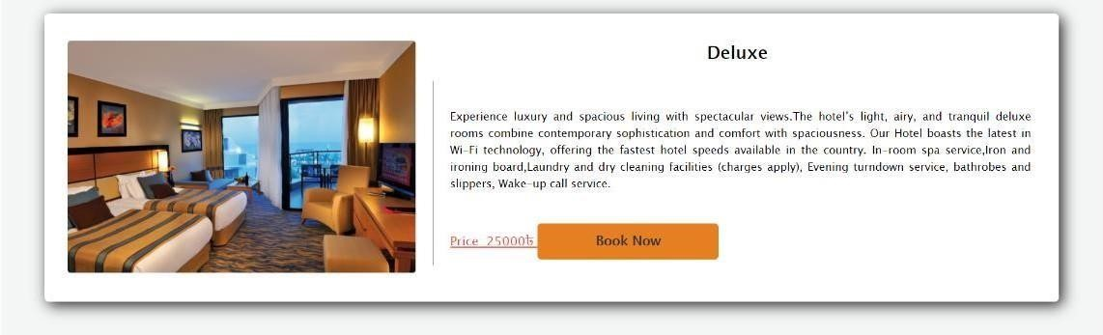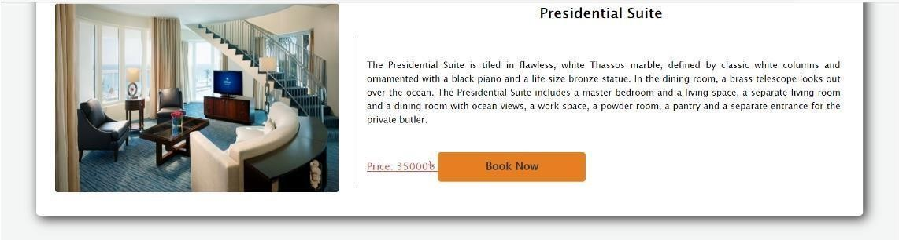

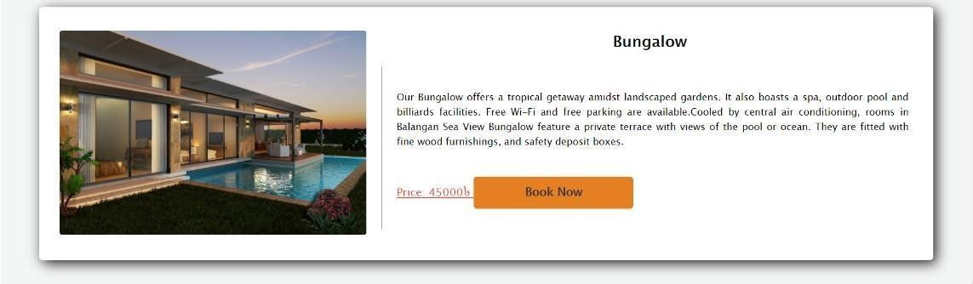

Fig 5.6: Room page
Resort Room means an area that is designed and constructed to be occupied by one or more persons on resort property, which is separated from others occupying the resort property. A resort room has securable entrance, and facilities for sleeping and sanitation.
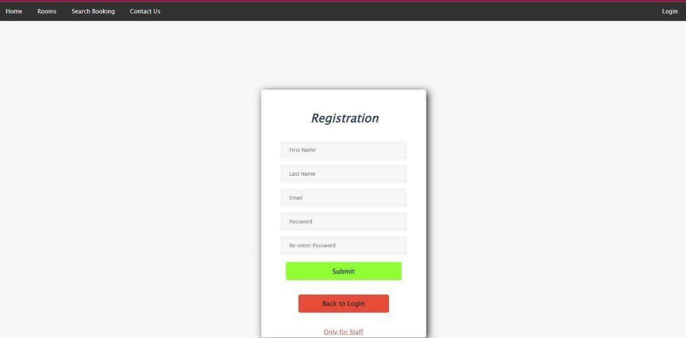

Fig 5.8: Registration page
A registration page enables users and organization to independently register and gain access to your system. It is common to have multiple signup pages depending on the types of people and organization you want to register.

CONCLUSION

The advantages of booking a resort online add up long before your arrival. Our legendary customer service extends to the web. One advantage of booking with the resort directly is the use of the resort’s full cancellation policy as well as not needing a deposite in most situations. Customer can read reviews and compare prices for Online Resort Booking. The most important advantage of online resort booking is convenience, you can book your rooms by simply sitting in home. Internet helps you to browse through the resorts around the world and compare the facilities and rates easily. Resort Management System is a room reservation site script where site users will be able to search rooms availability with an online booking reservations system. Site users can also browse resort, view room inventory, check availability, and book reservations in real-time. Site users enter check in date and check out date then search for availability and rates. After choosing the right room in the wanted resort, all booking and reservation process is done on the site and an SMS is sent to confirm the booking.

REFERENCES

- Fundamentals of Database System, Ramez Elmasri and Shamkant
B.Navathe, 7th Edition 2017, Pearson
- www.mysqltutorial.org
- https://getbootstraop.com/
- “Syntax”: https://https://stactoverflow.com/
- “tutorial”: https://www.phptpoint.com/

